Supplement till boken “Fatou – en syster I Gambia” av Rosalie Sanyang, skrivet av Fatou Toray daterat januari 2021

MY ACTIVITIES IN THE GAMBIA IN POLITICS AND WOMEN ISSUES
As we all know, the last regime has been a difficult moment for Gambians especially for women in all aspects of life. So from 2015, as a member of PDOIS myself together with the Party’s leadership and dedicated supporters started a campaign for coalition of opposition parties to be able to remove the former regime from power because the constitution if of a simple majority to win the election in which case no single opposition would have been able to win the former incumbent Yahya Jammeh. We went round the whole country to talk to people no matter which party they belong, we encouraged people to task their parties to come up with proposal on how they want a coalition of opposition parties to be formed. This helped in the formation of a coalition because people started asking parties to go back and discuss with other parties to form a coalition because that was the only way to remove Jammeh. PDOIS came up with a concept note on a formation of a coalition and invited all registered opposition political parties. UDP was not willing to join the talks so they started a countrywide tour but thanks to the sensitization campaign we waged earlier they were forced to come back and join the coalition talks. Eventually parties came together and formed a coalition that ushered in Adama Barrow as president.
Before the coalition talks, PDOIS held a congress in Bansang in 2016. But as you may know before 2016 there were very few women in the PDOIS executive, so I initiated a campaign for more women to be in the executive. Myself with few others started campaigning and talking to other women who are supporters of the party to be more involved in the party’s activities, get registered as party members to be able to participate in the congress, this helped a great deal in electing more women into the executive of the party at the 2016 congress. There is a women’s wing of the party which was not very active but after the 2016 congress it was reactivated and in 2019, the first ever congress of the women’s wing was held in Basse.
In 2017 I was involved in empowering women in politics campaign which was spearheaded by WANEP(West Africa Network for Peacebuilding) women were drawn from all registered political parties, we were trained on leadership skills amongst other things. Women were encouraged and motivated to vie for electoral office and in the 2017 legislative elections series of women applied through their parties to contest for the national assembly elections. Many of the women who applied were dropped by their party’s selection committee and this happened because most of the selection committee members are men, which is a clear manifestation of patriarchy. In PDOIS all the women who applied were nominated because we don’t have selection committees but we do primaries where contending candidates are elected by delegates and this delegates, comprise of one woman one man from each area. Unfortunately only 4 women applied under the PDOIS ticket and none got elected into parliament. The women empowerment program continued with mentorship sessions and in 2018 more women applied for councillorship and mayor/chairmanship. It resulted in a female mayoress being elected for the first time in the history of the Gambia and also series of women elected as councilors.
Apart from this personally I have been engaged in women empowerment in terms of skills, I engaged in training women on skills like soap making, cream and other products, in some trainings women are drawn from across the board but in most in stances I train women from PDOIS for them to be able to organize themselves, involve in income generating activities as groups and be able to help each other. This yielded fruits so many women groups got motivated to join PDOIS.
In 2019, as a beekeeper I was nominated by the ministry of women affairs to go to China to take part in a beekeeping training for 2 months through the office of the first lady. It was hectic but at the end of the training I came out as the most outstanding participant of the training. I returned to the Gambia and I am involving more women in training skills and political awareness.
I go to radio stations with other members of the party to sensitise people and in this radio talk shows I talk about issues affecting women and what are the programs of PDOIS to solve such issues. I also appear on TV to talk on women in PDOIS and our programs, this is motivating a lot of women. Now every week I go to a radio station and I also go to one women’s group to talk to them. With the women sensitization I involve training on skills if the funds are available which I raise myself by asking for women I know to donate which includes Rosalie though not much help is coming in that aspect but still the sensitization continues. With the radio talk shows we get funding from a group of PDOIS supporters in the diaspora that call themselves “VISION SYSTEM CHANGE” they pay for the radio programs and they also provide logistics for us such as transport and foods if we need any.
I am also involved in maintaining peace in the country so I am part of an Inter Party Committee (IPC) in seeing to it that there is peaceful co-existence between political parties of Halifa Sallah is the chairperson. I was representing my party at the regional level. I have been a member of the West Coast Region IPC and I have been the vice chairperson in that committee but as at present I have been moved from the regional level to the national level.
Also I am in another committee called Women In Peacebuilding, in this committee we don’t only discuss about politics but we discuss about everything that affects women in life, from love, marriage, child bearing, education, land etc. We build networks throughout the country and we come to the rescue of women and girls who are in need, and now with our involvement the ministry of women affairs created a free toll line for women to get quick help if they are in trouble and this number is 1313. We engage and help women who are in abusive relationships, women who are deprived of their inheritance and girls who are forced to get married, underage marriage, rape, violence in any form against women and girls who get withdrawn from school.
These engagements are having positive results because now women are getting bolder to come out and speak about violations they face in relationships or in their homes. Also it is emboldening women to take legal action in severe cases. More women are also taking independent decisions about their reproductive health and many now decide on when or when not to get a baby and how many babies one wants to have. The young generation women are now more independent, many don’t want to get married until they complete their education and they also get married to their choices of partners.
Myself and Amie Sillah are also part of a women group called Gender Action Team (GAT) under the auspices of the African Centre for Democracy and Human Rights Studies and this group is a member of a peacebuilding network of women in The Gambia, Senegal and Guinea Bissau and we have been actively involved in peace talk in the southern province of Senegal (Cassamance) and we’ve been holding talks with both the government and the rebel factions in Senegal. We were also very active in negotiating for peace in Gambia during the political impasse. We met with all the stakeholders and held talks with them especially the security heads to main peace. We also me with the president elect then Adama Barrow and held talk with him but unfortunately Jammeh refused to meet us. We also visited the border villages to see the conditions of refugees that flee the Gambia during the impasse and gave them support. We held peace marches in The Gambia, Senegal and Guinea Bissau.
This week I have been to my home town Gunjur to sensitise the youths on the party and on Sunday I will be in another part in Brikama to talk to a women’s group that also embraced PDOIS. Am also raising funds to have a skills training with 4 different groups soon if I get the required funds.
As I said Halifa is engaged in a lot of things. He is the chairperson of the Inter Party Committee, he is also engaging the government through the national assembly to bring back the draft constitution which was rejected by the same national assembly because most of them don’t understand it. I will try to get some write ups he did whenever I pass by the office because as you know am not working so I hardly go to the office.
I am attaching some pictures of activities I have been engaged in.
Fatou Toray, January 2021
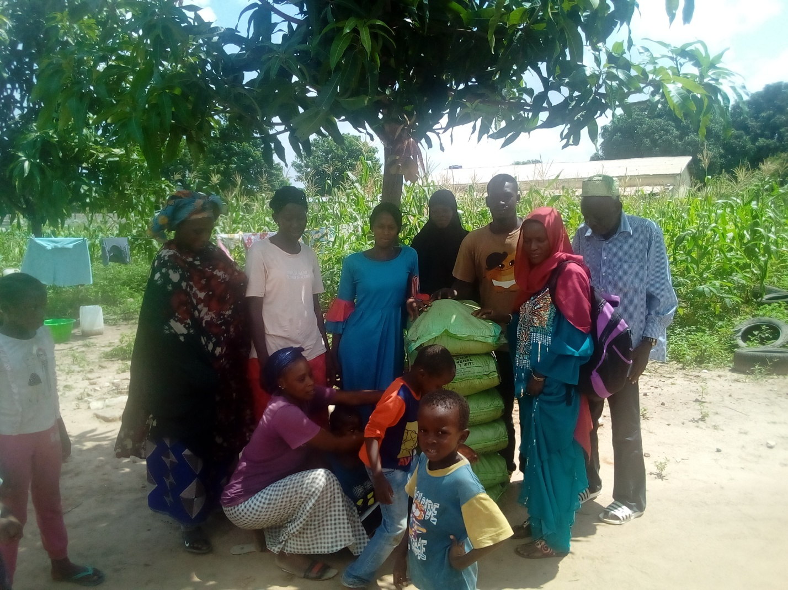
I donated fertilizer to PDOIS women in Jambanjelly during the rainy season

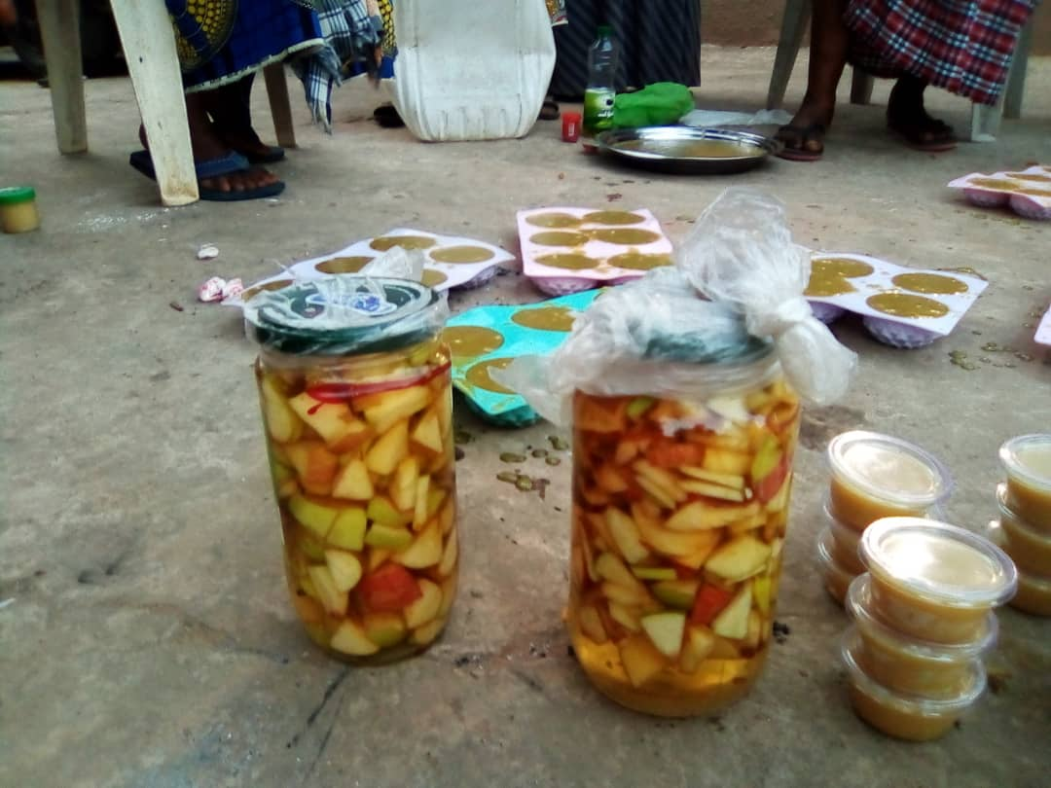
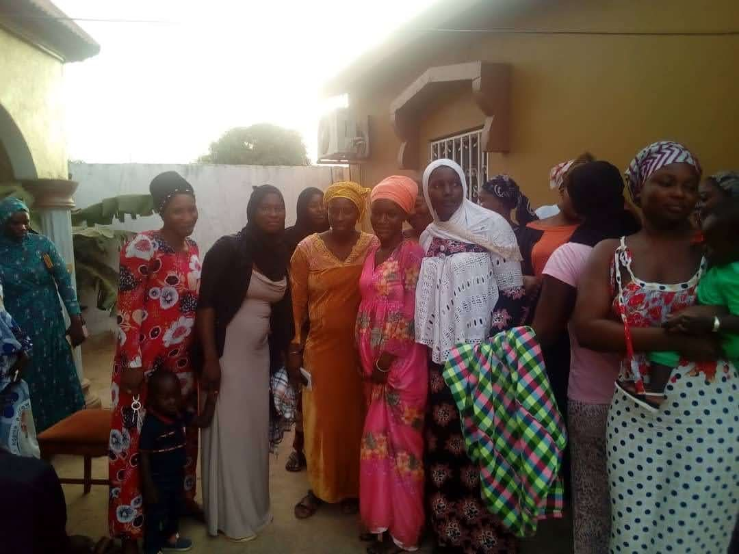
Some of the products I train women on and the group women that got the training

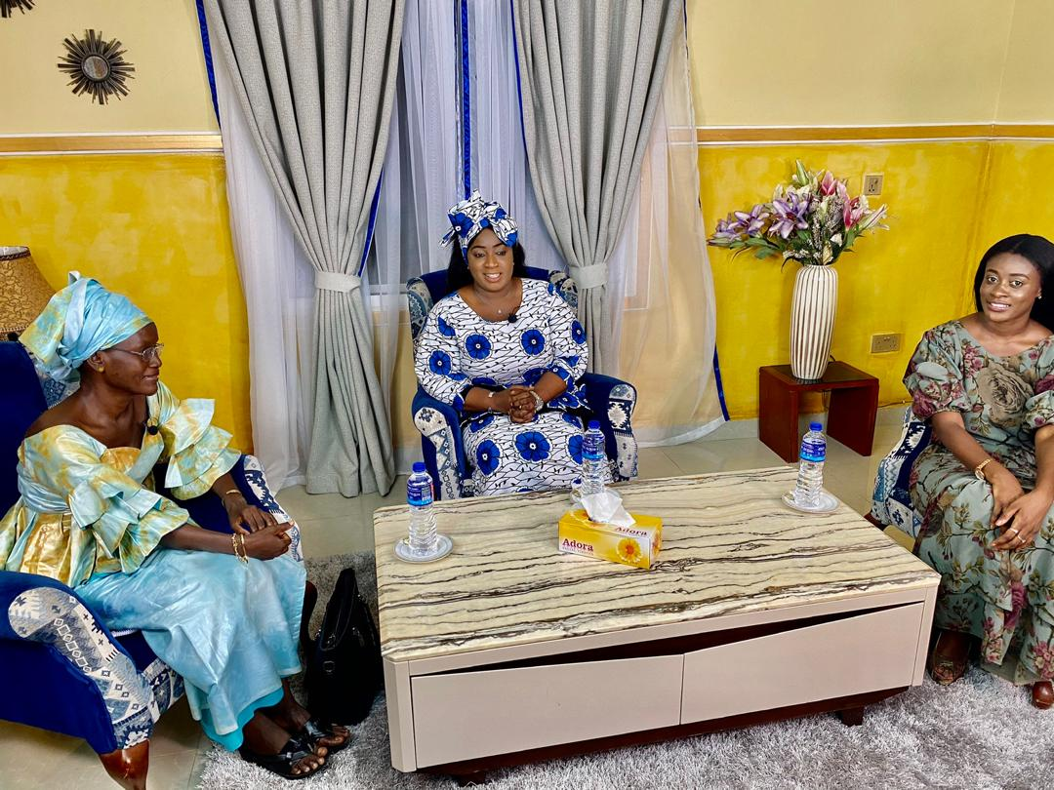
At GRTS talking about women in politics

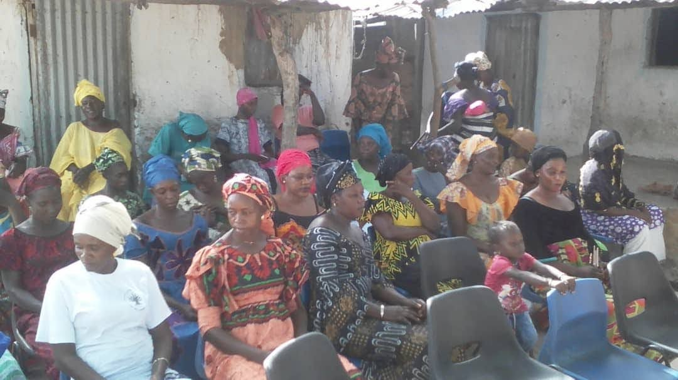
Sensitizing women in Ndungu Kebbeh NBR
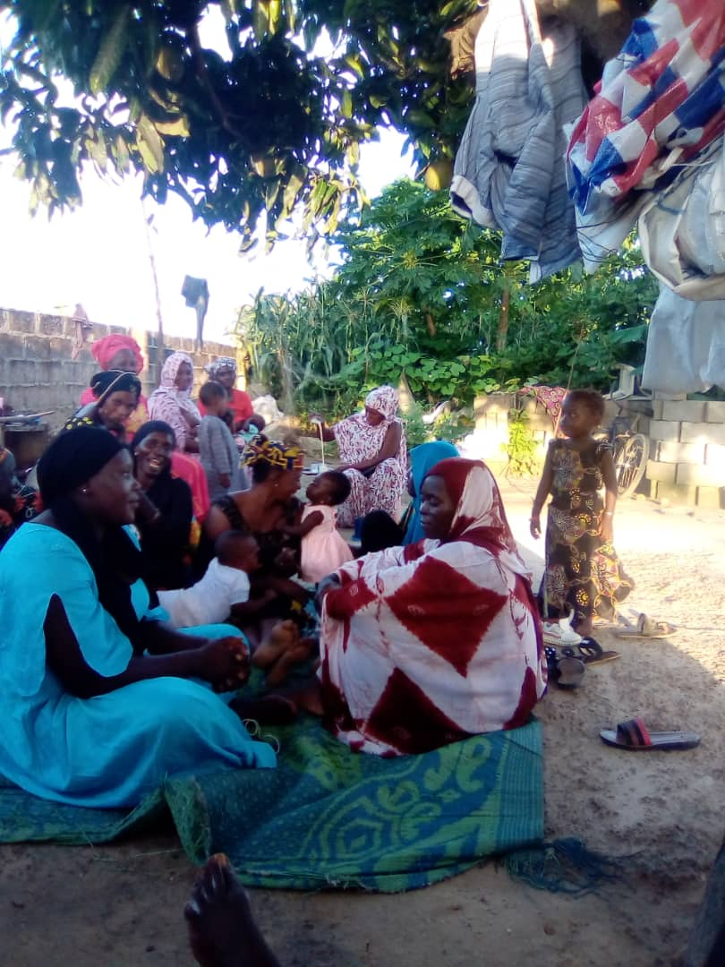
Talking to a women’s group in Farato about politics and their rights

Explaining about beekeeping the Gambia and our products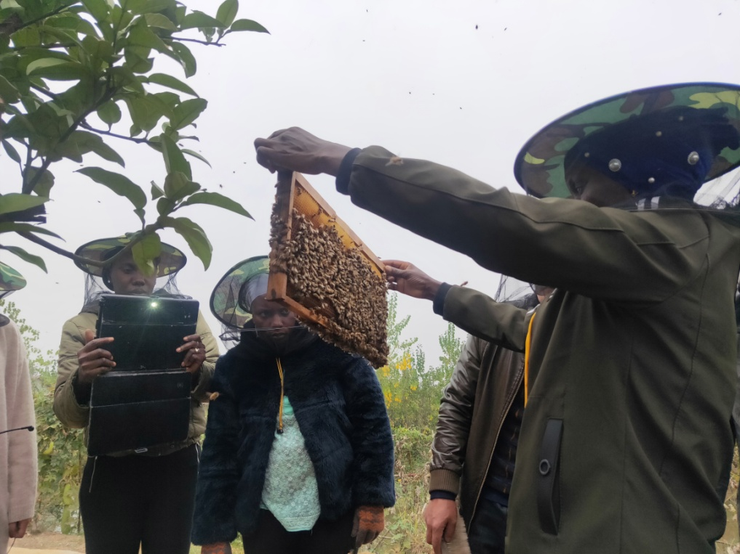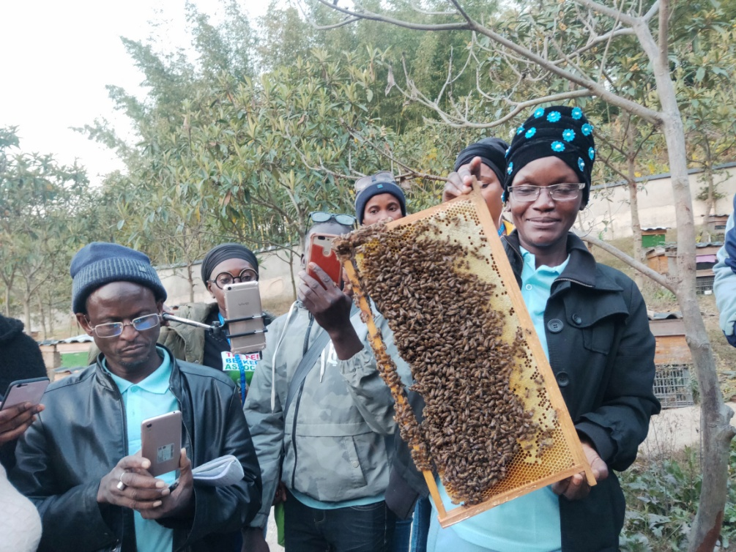
Showing the queen bee to the participants who are new in beekeeping

